Esquema Workbench (MySQL)

BASE DE DATOS: **bdempleados**

Srcipt SQL: 024 - BDEmpleados_MySQL_crear_estructura_e_importar_datos - **015.sql**

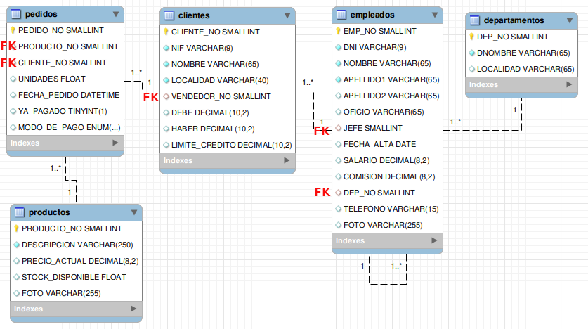

Esquema Workbench (MySQL)

BASE DE DATOS: **bdempleados**

Srcipt SQL: 024 - BDEmpleados_MySQL_crear_estructura_e_importar_datos - **015.sql**

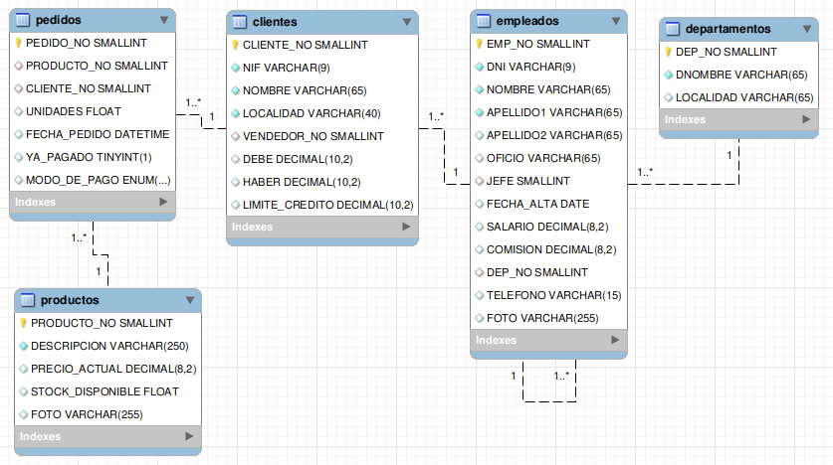



código que crea esta BD:

DROP DATABASE IF EXISTS bdempleados;

CREATE DATABASE bdempleados;

USE bdempleados;

-- -----------------------------------------------------

-- Table departamentos

-- -----------------------------------------------------

DROP TABLE IF EXISTS departamentos;

CREATE TABLE IF NOT EXISTS departamentos (

DEP_NO SMALLINT UNSIGNED NOT NULL,

DNOMBRE VARCHAR(65) NOT NULL,

LOCALIDAD VARCHAR(65),

PRIMARY KEY (DEP_NO)

);

INSERT INTO departamentos VALUES

(10,'CONTABILIDAD','BARCELONA'),

(20,'INVESTIGACION','VALENCIA'),

(30,'VENTAS','MADRID'),

(40,'PRODUCCION','SEVILLA')

;

-- -----------------------------------------------------

-- Table empleados

-- -----------------------------------------------------

DROP TABLE IF EXISTS empleados;

CREATE TABLE IF NOT EXISTS empleados (

EMP_NO SMALLINT UNSIGNED NOT NULL,

DNI VARCHAR(9) NOT NULL,

NOMBRE VARCHAR(65) NOT NULL,

APELLIDO1 VARCHAR(65) NOT NULL,

APELLIDO2 VARCHAR(65),

OFICIO VARCHAR(65),

JEFE SMALLINT UNSIGNED,

FECHA_ALTA DATE,

SALARIO DECIMAL(8,2) UNSIGNED,

COMISION DECIMAL(8,2) UNSIGNED,

DEP_NO SMALLINT UNSIGNED,

TELEFONO VARCHAR(15),

FOTO VARCHAR(255),

PRIMARY KEY (EMP_NO),

UNIQUE UQ_EMP_DNI (DNI),

UNIQUE UQ_EMP_FOTO (FOTO),

CONSTRAINT FK_EMP_DEP_NO

FOREIGN KEY (DEP_NO)

REFERENCES departamentos (DEP_NO)

ON UPDATE CASCADE,

CONSTRAINT FK_EMP_JEFE

FOREIGN KEY (JEFE)

REFERENCES empleados (EMP_NO)

ON DELETE SET NULL

ON UPDATE CASCADE

);

INSERT INTO empleados VALUES

(7839,'27449907M','Ana Patricia ','Rey','Primo','PRESIDENTE',NULL,'1981-11-17',600000,NULL,10,'981587147','./empleados/7839.jpg'),

(7698,'23229790C','Luis Manuel','Garrido','Díaz','DIRECTOR',7839,'1981-05-01',385000,NULL,30,'981246798','./empleados/7698.jpg'),

(7782,'22473780C','Juan Rodrigo Fernando','Rey','Manso','DIRECTOR',7839,'1981-06-09',245000,NULL,10,'981246798',NULL),

(7499,'34784976Y','María','Alonso','Gómez','VENDEDOR',7698,'1981-02-20',140000,40000,30,'',NULL),

(7521,'74340069K','Rosa María','López','Mas','EMPLEADO',7782,'1981-05-08',135000,0,10,'696547982','./empleados/7521.jpg'),

(7654,'27464555W','Ana','Martín','Calvo','VENDEDOR',7698,'1981-09-28',150000,160000,30,'983214589','./empleados/7654.jpg'),

(7844,'22941746M','Miguel','Calvo','Torrado','VENDEDOR',7698,'1981-09-08',180000,80000,30,'766514578','./empleados/7844.jpg'),

(7876,'50933568E','Jonathan','Gil',NULL,'ANALISTA',7782,'1982-05-06',335000,NULL,20,'981125147','./empleados/7876.jpg'),

(7900,'22461004D','Ana','Jiménez','Llul','EMPLEADO',7782,'1983-03-24',140000,NULL,20,NULL,NULL),

(8898,'22479862F','Rodrigo','Cortés','Cortés','VENDEDOR',7698,'1999-02-20',180000,NULL,30,'654879255',NULL),

(8902,'22453732M','Patricia','Garrido','Rey','VENDEDOR',7782,'2007-02-06',100000,0,NULL,'','./empleados/8902.jpg'),

(8904,'27460578G','Juan Manuel','Rey','Rey','',NULL,NULL,NULL,200000,NULL,NULL,'./empleados/8904.jpg')

;

-- -----------------------------------------------------

-- Table clientes

-- -----------------------------------------------------

DROP TABLE IF EXISTS clientes;

CREATE TABLE IF NOT EXISTS clientes (

CLIENTE_NO SMALLINT UNSIGNED NOT NULL,

NIF VARCHAR(9) NOT NULL,

NOMBRE VARCHAR(65) NOT NULL,

LOCALIDAD VARCHAR(40) NOT NULL,

VENDEDOR_NO SMALLINT UNSIGNED,

DEBE DECIMAL(10,2) UNSIGNED,

HABER DECIMAL(10,2) UNSIGNED,

LIMITE_CREDITO DECIMAL(10,2) UNSIGNED,

PRIMARY KEY (CLIENTE_NO),

UNIQUE UQ_CLI_NIF (NIF),

CONSTRAINT FK_CLI_EMP_NO

FOREIGN KEY (VENDEDOR_NO)

REFERENCES empleados (EMP_NO)

ON DELETE SET NULL

ON UPDATE CASCADE,

CHECK (DEBE <= LIMITE_CREDITO)

);

INSERT INTO clientes VALUES

(101,'22427339Q','DISTRIBUCIONES GOMEZ','MADRID',7499,300000,0,500000),

(102,'27438931T','LOGITRONICA S.L','BARCELONA',7654,0,120000,500000),

(103,'27465913A','INDUSTRIAS LACTEAS S.A.','LAS ROZAS',7844,0,NULL,1000000),

(104,'22918037D','TALLERES ESTESO S.A.','SEVILLA',7654,800000,0,1000000),

(105,'22478873F','EDICIONES SANZ','BARCELONA',7499,NULL,NULL,500000),

(106,'27447854E','SIGNOLOGIC S.A.','MADRID',7654,125,0,NULL),

(107,'27440525F','MARTIN Y ASOCIADOS S.L.','ARAVACA',7844,700000,0,1000000),

(108,'22456294Z','MANUFACTURAS ALI S.A.','SEVILLA',7654,0,1400,500000)

;

-- -----------------------------------------------------

-- Table productos

-- -----------------------------------------------------

DROP TABLE IF EXISTS productos;

CREATE TABLE IF NOT EXISTS productos (

PRODUCTO_NO SMALLINT UNSIGNED NOT NULL,

DESCRIPCION VARCHAR(250) NOT NULL,

PRECIO_ACTUAL DECIMAL(8,2) UNSIGNED,

STOCK_DISPONIBLE FLOAT UNSIGNED,

FOTO VARCHAR(255),

PRIMARY KEY (PRODUCTO_NO)

);

INSERT INTO productos VALUES

(10,'MESA DESPACHO MOD. GAVIOTA',55000,50,'./productos/10.jpg'),

(20,'SILLA DIRECTOR MOD. BUFALO',67000,25,'./productos/20.jpg'),

(30,'ARMARIO NOGAL DOS PUERTAS',46000,20,NULL),

(40,'MESA MODELO UNIÓN',34000,15,NULL),

(50,'ARCHIVADOR CEREZO',105000,20,'./productos/50.jpg'),

(60,'CAJA SEGURIDAD MOD B222',28000,15,NULL),

(70,'DESTRUCTORA DE PAPEL A3',45000,25,'./productos/70.jpg'),

(80,'MODULO ORDENADOR MOD. ERGOS',55000,25,NULL)

;

-- -----------------------------------------------------

-- Table pedidos

-- -----------------------------------------------------

DROP TABLE IF EXISTS pedidos;

CREATE TABLE IF NOT EXISTS pedidos (

PEDIDO_NO SMALLINT UNSIGNED NOT NULL,

PRODUCTO_NO SMALLINT UNSIGNED,

CLIENTE_NO SMALLINT UNSIGNED,

UNIDADES FLOAT UNSIGNED,

FECHA_PEDIDO DATETIME,

YA_PAGADO BOOLEAN,

MODO_DE_PAGO ENUM('CONTADO','TRANSFERENCIA','CHEQUE','TARJETA','PAGO ELECTRÓNICO'),

PRIMARY KEY (PEDIDO_NO),

CONSTRAINT FK_PEDIDOS_CLIENTE_NO

FOREIGN KEY (CLIENTE_NO)

REFERENCES clientes (CLIENTE_NO)

ON DELETE RESTRICT

ON UPDATE CASCADE,

CONSTRAINT FK_PEDIDOS_PRODUCTO_NO

FOREIGN KEY (PRODUCTO_NO)

REFERENCES productos (PRODUCTO_NO)

ON DELETE RESTRICT

ON UPDATE CASCADE

);

INSERT INTO pedidos VALUES

(1000,20,103,3,'1999-10-06 21:20:45',TRUE,'CONTADO'),

(1001,50,106,2,'1999-10-06 11:20:23',TRUE,'CONTADO'),

(1002,10,101,4,'1999-10-07 20:11:22',TRUE,'CONTADO'),

(1003,20,105,4,'1999-10-16 17:13:11',TRUE,'PAGO ELECTRÓNICO'),

(1004,40,106,8,'1999-10-20 18:33:26',TRUE,'PAGO ELECTRÓNICO'),

(1005,30,105,2,'1999-10-20 13:22:14',FALSE,'CONTADO'),

(1006,70,103,3,'1999-11-03 13:07:14',FALSE,'CONTADO'),

(1007,50,101,2,'1999-11-06 11:42:12',FALSE,NULL),

(1008,10,106,6,'1999-11-16 17:22:38',NULL,'CONTADO'),

(1009,20,105,2,'1999-11-26 20:05:00',NULL,'CONTADO'),

(1010,40,102,3,'1999-12-08 16:54:10',NULL,NULL),

(1011,30,106,2,'1999-12-15 15:11:12',TRUE,'TRANSFERENCIA'),

(1012,10,105,3,'1999-12-06 22:43:32',TRUE,'TRANSFERENCIA'),

(1013,30,106,2,'1999-12-06 11:20:22',TRUE,'TRANSFERENCIA'),

(1014,20,101,4,'2000-01-07 09:05:20',TRUE,'CHEQUE'),

(1015,70,105,4,'2000-01-16 12:22:34',TRUE,'CHEQUE'),

(1016,30,106,7,'2000-01-18 00:00:00',TRUE,'TARJETA'),

(1017,20,105,6,'2000-01-20 00:00:00',TRUE,'TARJETA'),

(1022,10,103,1,'2012-11-22 10:45:00',TRUE,NULL)

;